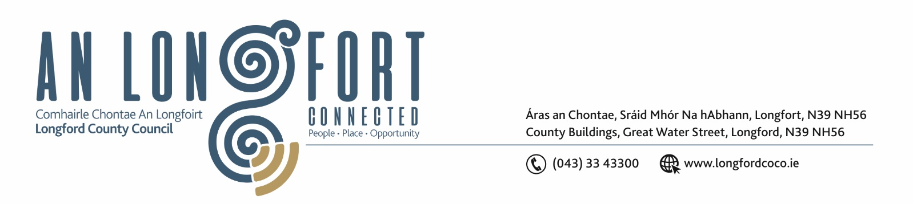

2u Mi na Samhna 2017

Chuig: Gach Ball don Chomhairle.

A Chomhairleoir,

Iarrtar ort bheith i láthair ag Cruinniú Míosuil Chomhairle Chontae Longfoirt a tionólfar i Seomra na Comhairle, Aras an Chontae, Longford ar an Chéadaoin, 8u Mi na Samhna 2017 ag 4.00 p.m chun gnó a dhéanamh d’réir an Chláir thíos.

You are requested to attend the Monthly Meeting of Longford County Council to be held in the Council Chamber, Aras an Chontae, Great Water Street, Longford on Wednesday, 8th November 2017 at 4.00 p.m. to transact business, as set out on the Agenda hereunder.

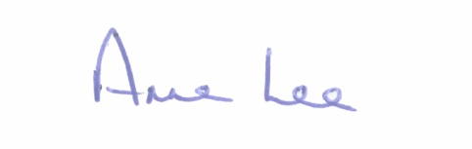
Mise le meas,

__________________
Anne Lee,
Meetings Administrator.

C L A R

- Confirmation of Minutes of Monthly Meeting of Longford County Council held on the
11th October 2017 – copy enclosed.

- Matters arising from Minutes.

- Consideration of the filling of casual vacancy in the Office of Leas Cathaoirleach of Longford County Council following the resignation of Councillor Padraig Loughrey – in accordance with Section 38 of the Local Government Act 2001.

- To note Chief Executive Orders - to follow.

5. To note Monthly Management Report - to follow.

6. To note adopted Minutes of Corporate Policy Group Meeting held on
13th September 2017 - (copy enclosed).

7. Finance & Information Systems.
(a) To note Public Liability Claims received during October 2017 – none.

(b) To fix Date for Finance “In Committee” Meeting.

8. Housing, Infrastructure, Environment & Emergency Services.

- Consideration of Loan Approval for Housing projects

(b) Consideration of disposal of Freehold Interest of Property at No. 59 The Demesne, Longford
to Elizabeth and Michael McGuckian in accordance with the terms of Section 183 of the Local Government Act 2001 issued on the 27th September 2017.

9. Economic and Community Development, Planning, Human Resources & Corporate Services, Cultural & Recreational Services.

- To note Planning Applications received since October meeting of the Council.

- Notice of proposed material contravention of Development Plan 2015 - 2021, Planning Applications Refs.
• PL17/13 - application for the proposed retention of the existing storage yard and all ancillary site works at Knock, Lanesboro, Co. Longford,
• PL17/50 - application for the proposed retention of existing car wash bay and all ancillary site works at Knock, Lanesboro, Co. Longford - Report to follow.

- To consider Legal Advice obtained by the Executive in relation to the possible
Variation of the County Development Plan - to follow.

- To note the Community Grant Support Scheme 2018 and to consider the recommendation of Longford Local Community Development Committee to apply its Equality and Human Rights Statement to the Scheme - enclosed.

- Update on review of the Development Contribution Scheme and proposed extension of the current Development Contribution Scheme 2013 – 2017.

- To fix date and venue for December meeting of the Council.

(g) Notices of Motions, submitted by Councillors, as listed hereunder -

Councillor Michael Carrigy.

“I call on Longford County Council to reduce the Development levies payable by people applying for planning in rural areas where there are limited services available.”

10. General
- Correspondence – circulated.

- Letter received on the 10th October 2017 from the Office of the Minister for Disabilities in relation to the ratification of the United Nations Convention on the Rights of Persons with Disabilities.
- Letter dated 18th October 2017 received from Failte Ireland regarding funding agreement between Failte Ireland and the Local Authorities for Regional Festivals and Participative Events in 2018.
- Correspondence received from the Office of the Minister for Housing, Planning and Local Government regarding Grants for the Provision of Water Supplies.
- Correspondence received from the Office of the Minister for Housing, Planning and Local Government regarding Water Services.
- Correspondence received from the Office of the Minister for Health regarding Long Term Illness Scheme.
- Correspondence received from the Office of the Minister for Health regarding Community Childcare Subvention Plus (CCSP) Scheme.
- Correspondence received from TUSLA regarding funding for Family Resource Centre Programme.

(ii) Notices of Motions, submitted by Councillors, as listed hereunder –

Councillor Michael Carrigy.

“I call on Longford County Council to engage with Longford/Westmeath Local Link to create a Town Link in Longford Town and its environs. This would provide a transport link for residents in estates to the town center, the Primary Care facility and St Josephs. It would also provide transport for the elderly to attend Club 89.”
“I call on Longford County Council to write to the HSE to seek funding to locate a Daycare Center for people in Longford who suffer with Dementia.There are over 1,000 people in Longford/Westmeath who suffer from this illness. “

11. Votes of sympathy.

12. Training -
Consideration of Report from Corporate Policy Group.



